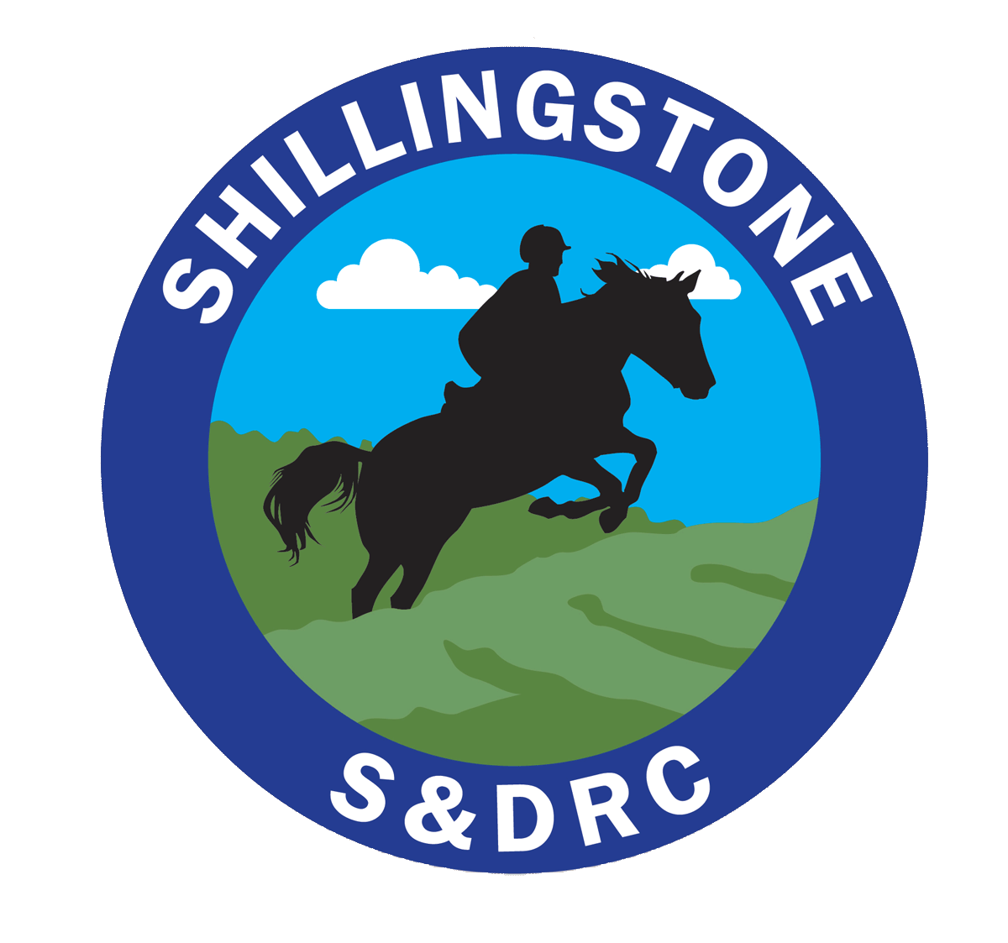Shillingstone & District Riding Club https://www.shillingstoneanddistrictrc.co.uk/
Summer Camp 2020 Application Form

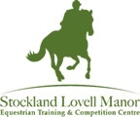
Stockland Lovell Manor - Equestrian and Competition Centre

Thursday 27 August arrive at 17:00 to Sunday 30 August 2020 leave at 17:00

We are inviting members of the South Western Dressage Group (SWDG) to join us this year.

All inclusive price to include:
- Accommodation (3 nights in log cabins)
- All food and beverages (Full English, lunch, cake and 2 course supper)
- Stabling (shavings hay or haylage)
- Instruction ( 3 hours per day in groups of 4-5)
- Use of Arenas and Cross Country Course (Show jumping, poles and flat work, dressage)
- Extensive cross country from baby course up to silly big AND Numerous hacking routes across the estate.
SDRC Member | Member of SWDG | Non Member | Non-riding member
£365 | £365 | £395 | £138
Deposit Payable on booking £75 – Non rider £50 - Final Payment on Monday 13 July 2020
Details
Name

Address/
Postcode

Email
Phone
Attending as | SDRC member  Riding |  | Not a member of SDRC or SWDG  Riding
 | SWDG member  Riding |  | Non riding member

Horse Details | Horse 1 | Horse 2
Horse Name
Passport Name

Passport Number
Last Flu Vaccination |  | Horse must have received a flu vaccine booster between 1 March 2020 and 19 August 2020

Rider/Horse Level |  | Notes/ information that will help us organise riding groups
Flat work/Dressage | General flat work  Prelim- Novice -Elementary
Show Jumping | Poles and small jumps  60cm- 70cm- 80cm- 90cm-100cm-110cm
Cross Country | Just starting, confidence building  60cm- 70cm- 80cm- 90cm-100cm-110cm
Other interests/requests | Musical ride/ hacking/ equine lectures
Are you happy for photographs or you/your horse to appear of the club website and facebook page? |  | Yes/ No

Accommodation |  | Notes/ information that will help us
Preferred accommodation (you can opt to sleep in your lorry cost is the same) | 7 log cabins - 5 with 3 beds, and 2 with 4 beds  The Old Workshop - 6 + 6 beds  Sweeps Barn - 5 + 5 beds | (Any requests to share with friends – we will do our best to try to sort this)
Diet | Vegetarian/ Vegan/ Gluten Free
Stabling | Shavings are provided along with hay or haylege

Please check that you are happy to abide by the camp rules: (set by SDRC and Stockland Lovell Manor)
- I will ensure that my horse’s vaccinations are up to date in line with Stockland Lovell recommendations. I will include evidence of this. Failure to meet these regulations, will sadly result in cancellation of the place and a refund is unlikely
- I am responsible for the health and safety of myself and my horse; I will ensure my tack is in a safe and serviceable condition.
- I will treat other members, instructors and club officials with respect. I appreciate the impact of my behaviour on others, value differences, recognising that we will not all share the same views
- I will attend the safety briefing and make sure I understand my responsibility to follow the guidance and rules associated with the enjoyment of the facilities at Stockland Lovell Manor
I confirm that I have read and agree to the conditions above.
Electronic Signature:__________________________________________________________________
Name: _____________________________________________________________________
Date:_____________________________________________________________________
To complete your camp application
Email the completed from to shillingstone@hotmail.com
Make a payment of the deposit with reference CAMP 2020 of £75 or £50 to:
- Bank Transfer to S&DRC acc. 70014482 sort code 09-01-54 with your surname as reference - Or
- Cheque to Shillingstone and District Riding Club
Thank you, we will confirm you place on camp. Keep an eye of the website for further information.
https://www.shillingstoneanddistrictrc.co.uk/

