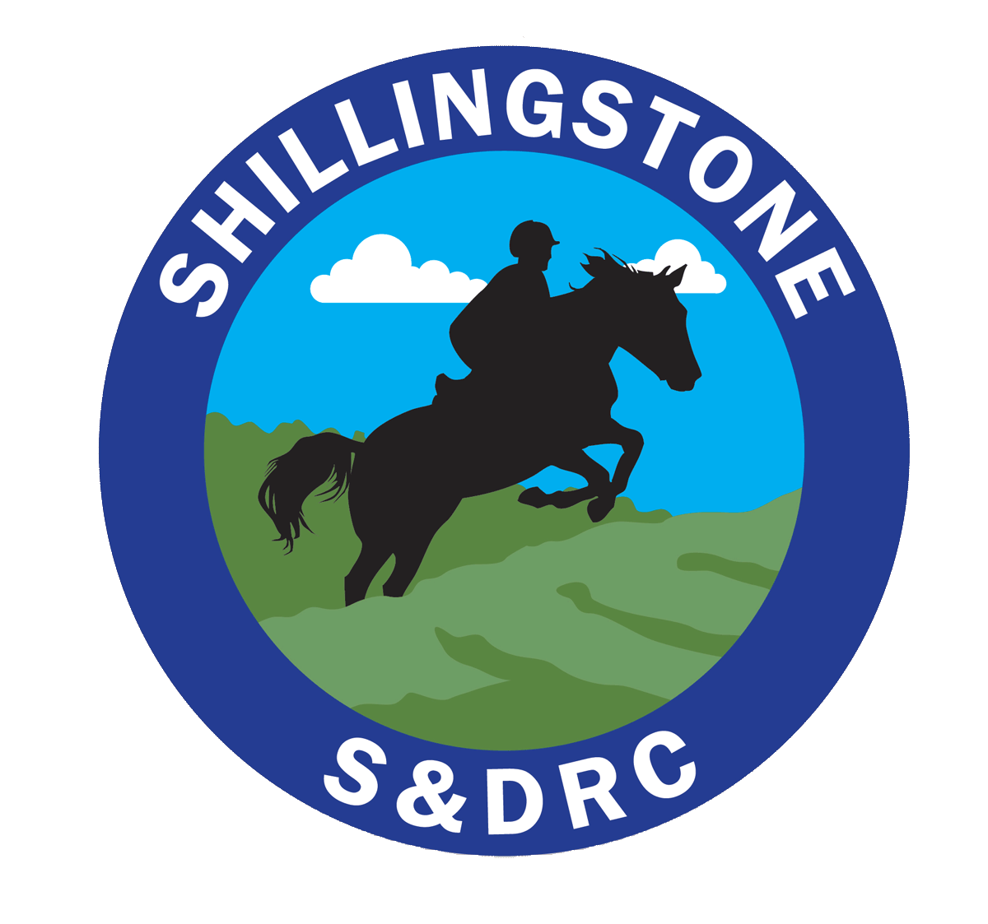
Shillingstone & District Riding Club
https://www.shillingstoneanddistrictrc.co.uk/
Membership Application Form
(Information held in accordance with GDPR – Details on website)

New Riding member | Existing Riding member paid before 1st January each year | Existing Riding member paid after 1st January up until 30 March | Non-riding member
£25 | £23 | £25 | £18
Membership fees (subscriptions fall due on 1st January each year, and are valid for 12 months)

Rider Details
Name

Address/
Postcode

Email
Phone
Membership | Riding member |  | Non riding member

Horse Details | Horse 1 | Horse 2
Horse Name
Passport Name

Passport Number
Affiliations | BE/BS/BD/ OTHER | BE/BS/BD/ OTHER
Interests | Dressage- Show Jumping- X Country- Hacking- Camp – Horsemanship  Other
Are you happy for photographs or you/your horse to appear of the club website and facebook page? |  | Yes/ No

Please check that you are happy to abide by the club rules: (full copy of the constitution is available on the web-site)
- I hold public liability insurance for my horse and riding activities and will include evidence of this with my application
- My horse’s vaccinations are up to date in line with BRC recommendations. I will include evidence of this with my application and will ensure the club holds up to date records of all subsequent boosters.
- I am responsible for the health and safety of myself and my horse; I will ensure my tack is in a safe and serviceable condition.
- I will wear the correct safety equipment, riding hat/skull cap, which conforms to current BRC safety standards. Body protectors are MANDATORY for cross-country jumping – the body protector must be Level 3 2009 (Purple label).
- I understand that I am liable for the cost of any damage caused to property and equipment by myself, my horse, my vehicle, or any person in my party.
- I will treat other members, instructors and club officials with respect. I appreciate the impact of my behaviour on others, value differences, recognising that we will not all share the same views
- I am willing to volunteer at least ½ day a year towards the running of events, clinics or competitions, if I compete in BRC qualifiers I will also volunteer at one event a year, if required.
I confirm that I have read and agree to the SDRC rules above.
Electronic Signature:__________________________________________________________________
Name: _____________________________________________________________________
Date:_____________________________________________________________________
To complete your membership:
Email the following to shillingstone@hotmail.com
- Completed membership form
- Copy of horses passport- pages with horses details, vets identification and vaccination record- saved as word of jpeg
- Evidence of public liability insurance
Make a payment of the membership fee to:
- Bank Transfer to S&DRC acc. 70014482 sort code 09-01-54 with your surname as reference - Or
- Cheque to Shillingstone and District Riding Club
Thank you, we look forward to welcoming you to the club

