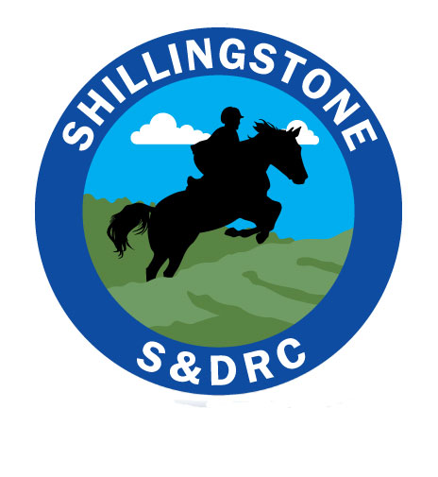

Refund Policy
Refunding clinic/entry fees, including camp.

Principles:

We understand that horses are unpredictable creatures and the nature of the sport is such that having to cancel a booked place often due to rider or horse injury or illness is frequent. Therefore whenever possible we will endeavour to refund as much of a paid fee as possible.

Equally however we are responsible for the financial viability of the club.

Refunds- Clinics

Clinics are usually booked via Equo, at a cost to both the rider and club. Once a booking and payment is made a refund is not usually possible. However if you are able to find a replacement we will refund the full amount minus an administration charge of £5.

If the clinic is running at a profit of 20% and you are unable to find a replacement we will refund the amount minus £5 administration charge.

Refunds- Guided Rides

These rides are charged at £5 so once a booking is made this amount in non-refundable.

Refunds - BRC Team Events

At the time of booking the entry fee is payable to the club account. The team manager will also make a prelim entry fee, the club funds this fee.

If you need to withdraw your entry from either the team or individual you must inform the team manager as soon as possible. If you or the committee are unable to find a replacement rider you will need to negotiate a refund with the event organiser. The club will cover the prelim fee paid to BRC.

Refunds- Summer Camp

At the time of booking a deposit is paid. This deposit is non-refundable unless the camp bookings are above the minimum required number.

Once a full payment has been made to secure the venue for camp, usually 4 weeks before the event, a refund is not usually possible.

If camp is running at a profit of 20% and you are unable to find a replacement we will refund as much of your fee as funds will allow us to.

