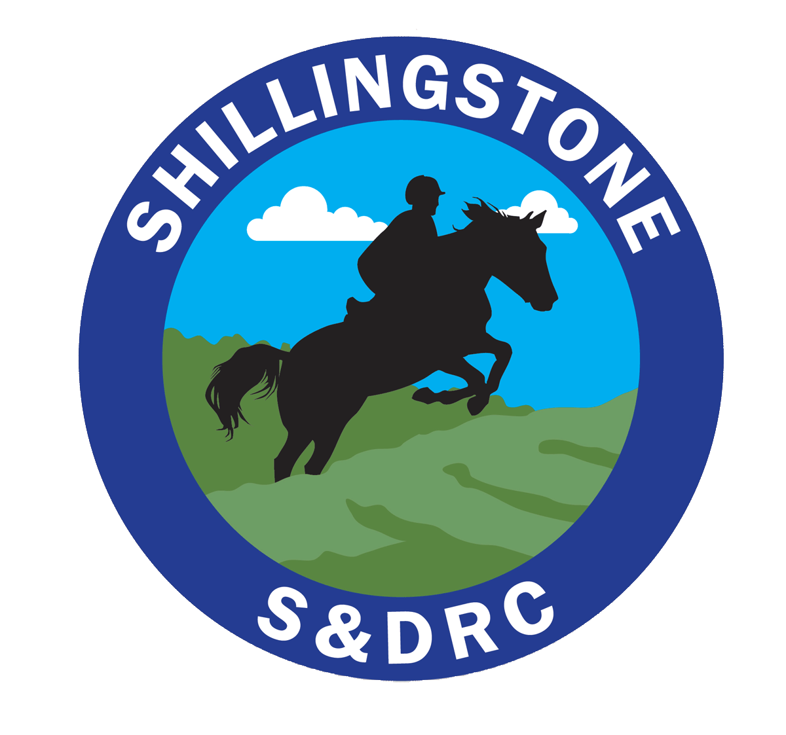
Shillingstone & District Riding Club
https://www.shillingstoneanddistrictrc.co.uk/
Membership Renewal
(Information held in accordance with GDPR – Details on website)
Renewal Riding member paid before 31st January | If full membership fee is not paid by 31 January the new member fee will be charged | Renewal Non Riding member
£25 | £35 | £18
Membership fees (subscriptions fall due on 1st January each year, and are valid for 12 months)
Please can you confirm your details so we can ensure our records are up-to-date.
Rider Details
Name

Email
Membership | Riding member |  | Non riding member
Please confirm that you are happy to abide by the club rules: (full copy of the constitution is available on the web-site)
- I hold public liability insurance for my horse and riding activities and will include evidence of this with my application
- My horse’s vaccinations are up to date in line with BRC recommendations. I will ensure that my horse is vaccinated in accordance with the requirements of all the equestrian venues I visit (minimal of annual vaccinations)
- I am responsible for the health and safety of myself and my horse; I will ensure my tack is in a safe and serviceable condition.
- I will wear the correct safety equipment, riding hat/skull cap, which conforms to current BRC safety standards. Body protectors are MANDATORY for cross-country jumping – the body protector must be Level 3 2009 (Purple label).
- I understand that I am liable for the cost of any damage caused to property and equipment by myself, my horse, my vehicle, or any person in my party.
- I will treat other members, instructors and club officials with respect. I appreciate the impact of my behaviour on others, value differences, recognising that we will not all share the same views
- I am willing to volunteer at least ½ day a year towards the running of events, clinics or competitions, if I compete in BRC qualifiers I will also volunteer at one event a year, if required.
I confirm that I have read and agree to the SDRC rules above. Electronic Signature:__________________________________________________________________Date:____________________________________________________________________
Email the following to shillingstone@hotmail.com
- Completed membership form
- Make a payment of the membership fee to:
Bank Transfer to S&DRC acc. 70014482 sort code 09-01-54 with your surname as reference

