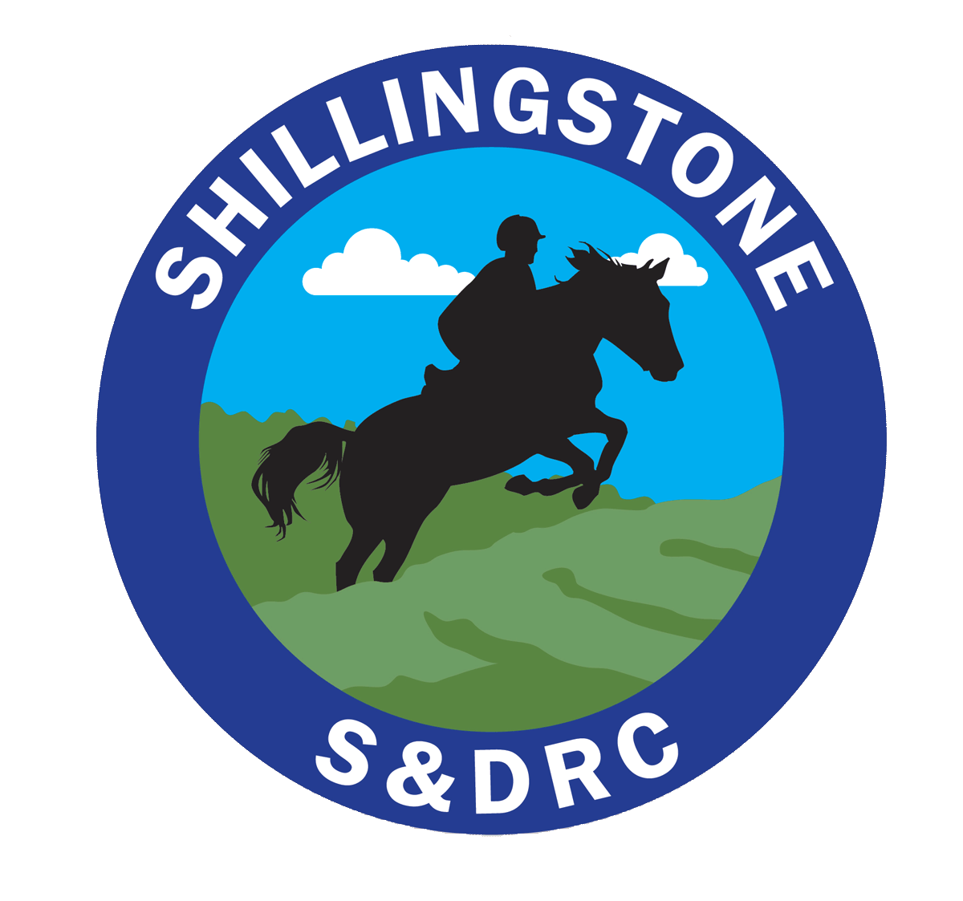
Shillingstone & District Riding Club
Membership Application Form
(CONFIDENTIAL WHEN COMPLETED)
I wish to join the Shillingstone & District Riding Club as a*Riding / *Non Riding member
Name: _____________________________________ Mr / Mrs / Miss / Ms
Address: _________________________________________________________________________
Post Code: ____________________ Tel Numbers: __________________________________
E-mail address: ___________________________________________
Membership fees (subscriptions fall due on 1st July each year, and are valid for 12 months)
New Riding member | Existing Riding member paid before 1st July ‘2018 | Existing Riding member paid after 1st July 2018 | Non-riding member
£25 | £23 | £25 | £18

Please indicate your interests*
Dressage - Show Jumping - X-Country – Trec – Hacking – Horsemanship - Instruction - Other

Are you happy for photographs of yourself/your horse to appear on the Club website*Yes / No
The Club website gives details of the clubs GDPR statement – under the about us section
^{Horse details} | ^{Horse 1} | ^{Horse 2}
^{Stable Name}
^{Passport Name}
^{Passport Number}
^{Affiliations*} | ^{BE / BS / BD / Other} | ^{BE / BS / BD / Other}

Payment information on second page

Signed.................................................................................... Date ........................................

^{Payment (tick as appropriate)}

    - Cheque to Shillingstone and District Riding Club
    - Bank Transfer to S&DRC, acc. 70014482, sort code 09-01-54 with your surname as reference

Please send completed forms to Kathy Westby, Altwood, Winterborne Houghton, Blandford Forum, Dorset, DT11 0PE or by email to kathyandmike@btinternet.com
Please note that all members partaking in an Area Competition are required to assist at a minimum of one event per year.

Please complete the disclaimer form on the next page.

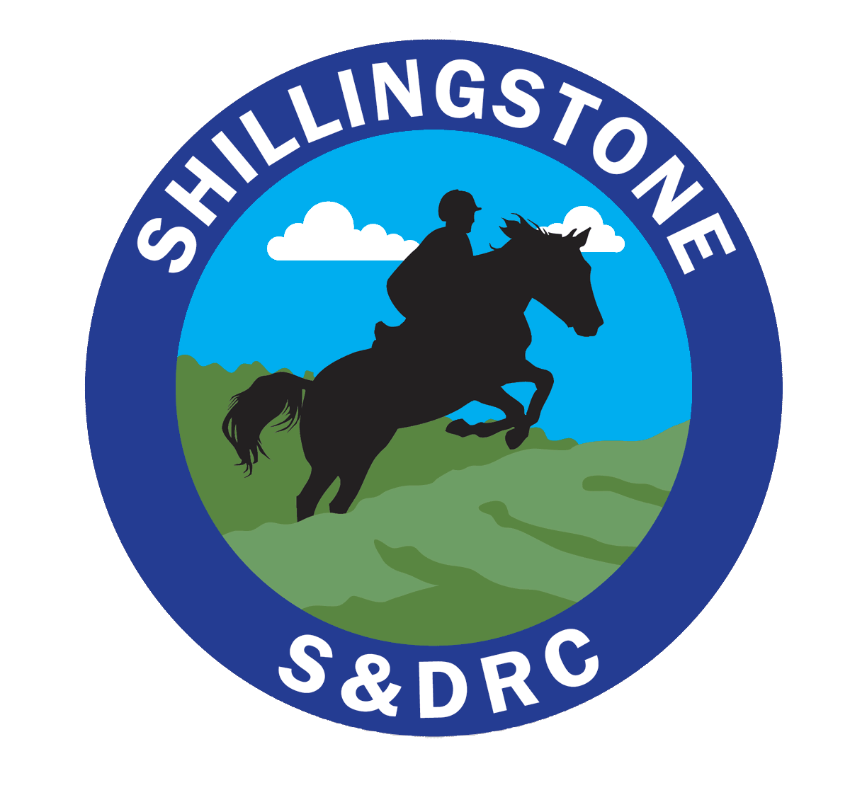
THIRD PARTY DISCLAIMER FORM
I confirm that I have read the Clinic Rules below. I understand that riding at any standard has inherent risk and that I may be injured. I accept that risk and agree that neither the Shillingstone & District Riding Club, Riding Instructor, nor the Venue will be liable for injury or damage to property unless it is caused by their negligence.
Signature:__________________________________________________________________
Name: _____________________________________________________________________
Date:______________________________________________________________________
Membership number:________________ Organisation: ____________________________
Own Insurance Provider: ______________Type of Cover:___________________________
Clinic Rules
- I have appropriate public liability insurance and must provide evidence of this (schedule/cover note/Membership number).
- Insurance: All Riding Club members are covered by third party insurance. Any one attending the event that is NOT a riding club member, i.e. groom, should take out their own Third Party Insurance. Shillingstone & District Riding Club strongly recommends that all riding club members hold their own personal accident insurance in addition to the insurance cover provided by their BRC membership.
- I understand that riding and being around horses has inherent risk and that all horses may react unpredictably. I accept that risk.
- Correctly secured British Riding Hats BRITISH PAS 015:1998 or 2011 provided they are either BSI Kite marked VG1 01.040:2014-12, EUROPEAN VG1 01.040:2014-12, AMERICAN ASTM F1163:2004a or 04a onwards, alternatively they are SEI marked SNELL E2001 AUSTRALIAN & NEW ZEALAND AS/NZS 3838:2006 onwards provided they are SAI global marked; that meet current Safety Standard MUST be worn by riders at all times when mounted.
- I understand it is my choice whether or not I wear a body protector in the arena. Body protectors are MANDATORY for cross-country jumping – the body protector must be Level 3 2009 (Purple label).
- I understand that it is my responsibility to ensure my tack is in a safe and serviceable condition.
- I understand that I am liable for the cost of any damage caused to property and equipment by myself, my horse, my vehicle, or any person in their party.
- I understand that my instructor will make decisions based on information I give them and I agree to always be honest and volunteer information about: my abilities and riding experience; any previous riding accidents; any medical condition(s) which may affect my ability to ride. It is up to me to ensure that I have the experience and ability to undertake the ridden tasks and to decline any activity which I feel is beyond my capabilities.

