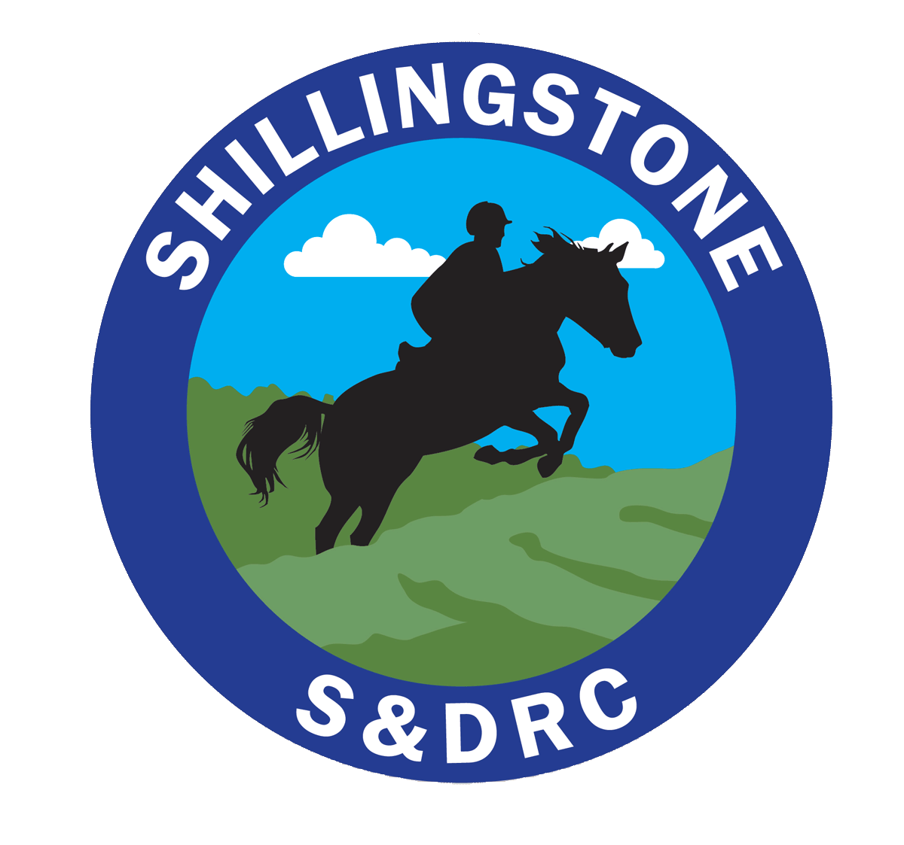Shillingstone & District Riding Club https://www.shillingstoneanddistrictrc.co.uk/
Booking/Entry form
Saturday 10 October – Ready to ride at 10:30 am
Guided Ride
Meet at The Fox - Ansty DT2 7PN
Members only
Details
Name

Email
Phone
Any special requests in relation to the ride
We will be cantering but will be sure to take care of you all and not bomb off!

Please remember your high vis!
Make a payment of the deposit with reference Fox ride of £5 to:
- Bank Transfer to S&DRC acc. 70014482 sort code 09-01-54 with your surname as reference - Or
- Cheque to Shillingstone and District Riding Club
I confirm that I have read and agree to follow the SDRC Covid risk assessment: (Available at: https://www.shillingstoneanddistrictrc.co.uk/riskassessment
Signed (electronic) |  |  |  | Date

Please make any necessary payments and email this form to: Shillingstone@hotmail.co.uk

