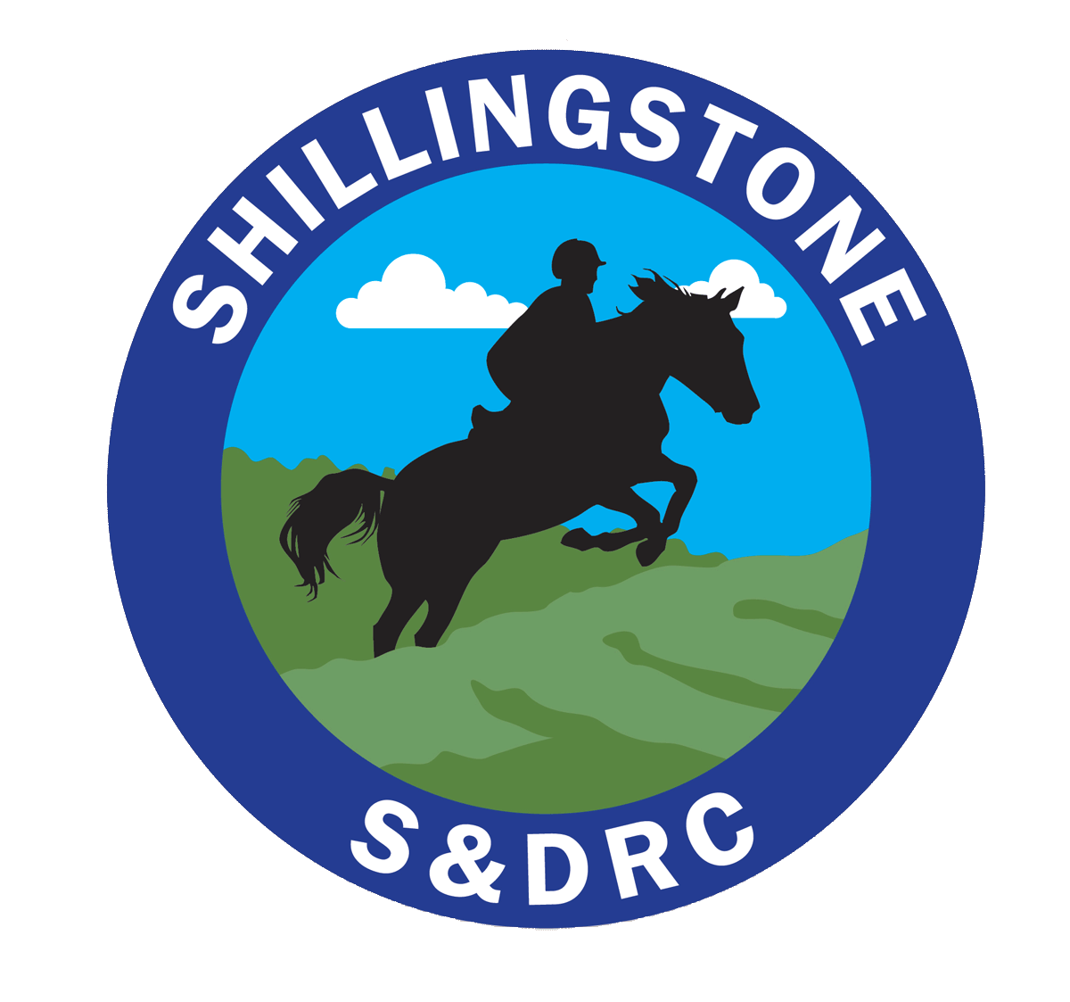Shillingstone & District Riding Club https://www.shillingstoneanddistrictrc.co.uk/
Booking/Entry form
Monday 19 October Starting at 10:30 am
Stour Cross Country
Details
Name

Email
Phone
Please state your preferred height
Please remember your back protector
Members : £37
Non members: £40
Make a payment of the deposit with reference Stour Cross to:
- Bank Transfer to S&DRC acc. 70014482 sort code 09-01-54 with your surname as reference - Or
- Cheque to Shillingstone and District Riding Club
I confirm that I have read and agree to follow the SDRC Covid risk assessment: (Available at: https://www.shillingstoneanddistrictrc.co.uk/riskassessment
Signed (electronic) |  |  |  | Date

Please make any necessary payments and email this form to: Shillingstone@hotmail.co.uk

