BRC Area 17
Combined Training Qualifier
organised by New Forest Riding Club
This event is a qualifier for the NAF 5 Star Combined Championships on 21-22nd May 2022 at Washbrook Farm, Aston-le-Walls, Daventry, Northamptonshire. NN11 6RT

Sunday 3rd April
at
Sparsholt College, Equine Centre
Westley Lane, Sparsholt, Winchester, SO21 2NF

Official Steward: Nick Fincham
Course Builder: Zoe Pyatt
Judge: Di Longland
Paramedic: Medic One
Photographer in attendance
Vet on Call
Catering provided

ORGANISER and ENTRIES SECRETARY:
Amy Robbins
07803537369 (after 5pm only)
amy.robbins@hotmail.co.uk
17 Green Close, Whiteparish, Salisbury, SP5 2SB

PRELIM entries to BRC close on Friday 12th March 2022
Detailed Entry Forms need to be submitted by Friday 25th March 2022

Times will be emailed to Team Managers and will be available on the
Area 17 website by 7pm Thursday 31st March
http://www.area17-brc.org.uk/

Course walk and start times will be clearly stated when the rider times are published

Passport copies of all horses in qualifying classes must be up to date and held on the Area 17 Database by entry closing date. Flu vaccination record must comply with the 2022 updated policy in section G7.1 of the handbook. This will be checked to ensure that each horse is on the shared drive and accepted.

Schedule
Teams of four with the best three scores to count and individuals. Two team members compete in the Prelim/75 section and two in the Novice/85 section.
There are also 2 extra individual only sections for seniors and juniors comprising of Novice/75 and Prelim/85.
Competitors can enter as a team and an individual but the jumping height must be different.
Dressage tests will be ridden before the jumping phase. Dressage to be outdoors, jumping indoors.

Class 1 |  | Junior CT Team Qualifier
1 rider at Prelim 7 & 75cm (no BE/BS points or BD at Novice or above)
1 rider at Prelim 14 & 75cm (no BE/BS points or BD at Novice or above)
1 rider at Novice 24 & 85cm
1 rider at Novice 30 & 85cm
Entry fee £120 per team

Class 2 |  | Senior CT Team Qualifier
1 rider at Prelim 7 & 75cm (no BE/BS points or BD at Novice or above)
1 rider at Prelim 14 & 75cm (no BE/BS points or BD at Novice or above)
1 rider at Novice 24 & 85cm
1 rider at Novice 30 & 85cm
Entry fee £120 per team

Class 3 |  | Senior or Junior Prelim CT Individual Qualifier (specify on entry)
Prelim 7 & 75cm (no BE/BS points or BD at Novice or above)
Entry fee £30 per individual
Class 4 |  | Senior or Junior Prelim CT Individual Qualifier (specify on entry)
Prelim 14 & 75cm (no BE/BS points or BD at Novice or above)
Entry fee £30 per individual

Class 5 |  | Senior or Junior Novice CT Individual Qualifier (specify on entry)
Novice 24 & 85cm
Entry fee £30 per individual

Class 6 |  | Senior or Junior Novice CT Individual Qualifier (specify on entry)
Novice 30 & 85cm
Entry fee £30 per individual

Class 7 |  | Open Junior and Senior Prelim CT Individual Qualifier (new format)
Prelim 12 & 85cm (no BD points at Novice or above)
State whether Junior or Senior on Entry Form
Entry fee £30 per individual

Class 8 |  | Open Junior and Senior Novice CT Individual Qualifier (new format)
Novice 27 & 75cm (no BE/BS points)
State whether Junior or Senior on Entry Form
Entry fee £30 per individual

Reporting to the steward
All riders should present to the Tack Check Steward a minimum of 20 minutes before their time. It is the responsibility of the rider to ensure their tack and equipment conform to the rules. Full details are in the current BRC Handbook.
Competitor numbers
Competitors must provide their own numbers, either as two bridle numbers, two numnah numbers, a back number or within a number bib.
Competitors should print off an additional number which must be displayed on vehicle windscreens to speed up checking on entry to the site.
Competitors should limit the number of spectators they bring with them, to limit the spread of Coronavirus.
HELPERS
Each participating Club will be required to provide names and contact details of 1 helper (full day) or two helpers (half day). The Relevant form will be sent to each participating Club and must be returned with the area entry form. Social distancing recommendations will be followed.
ENTRIES
Pre-entries required to the BRC office by Friday 12th March 2022 using the online portal here: brc.bhs.org.uk.
Area entries to be made to Amy Robbins via email to amy.robbins@hotmail.co.uk by Friday 25th March 2022 using the official entry forms on the Area 17 Website and on the BRC website here: BRC Entry Forms | British Horse Society (bhs.org.uk)

Payment should be made via BACS to NEW FOREST RIDING CLUB,
sort code: 20-53-53 acc no: 40393835 reference: AREA CT (insert club name).
If sending a cheque, please address to NEW FOREST RIDING CLUB and send to 17 Green Close, Whiteparish, Salisbury, SP5 2SB.

DECLARATIONS
Forms no longer required. Any simple changes must be made to the secretary before the class starts.
The deadline for complex substitutions will by 12pm Thursday 31st March.. A complex substitution is one where teams are re-arranged, or horse and rider combinations are moved from one team to another. Simple ones are where a horse and/or rider replace(s) the withdrawn one in the same team and position.

RULES

This competition will be run in accordance with the official rules for all British Riding Club Competitions 2022 and in addition, the latest guidance from BRC regarding Covid-19 precautions. Area 17, New Forest Riding Club, and persons acting on their behalf, do not accept any liability for any loss, accident or damage to any person, animal, vehicle or goods occurring in connection with this event. It is a condition of entry that each competitor indemnifies the organiser against any claim.

To qualify for the relevant British Riding Club Championships, entries must be made through clubs on the official forms.
Competitors only are allowed to ride the horse on the showground. Everyone mounted must wear a hard hat with the harness adjusted and fastened.
Under BRC rules, any rider who has a fall from their horse anywhere on the showground must see the paramedic before remounting and follow their instructions. The paramedics decision is final. Any breach of this rule will be reported to the Official Steward. Team managers are responsible for making sure all riders understand and accept this rule.

The Passport/Vaccination Certificate must, under penalty of elimination, accompany the horse to all official competitions. The competitor is responsible for producing it on demand.

The Organisers of this competition have taken reasonable precautions to ensure the health and safety of everyone present. For these measures to be effective everyone must obey the instructions of the Organisers, Officials and Stewards and take all reasonable precautions to avoid and prevent accidents occurring. A Paramedic will be available, and the event will be run in line with BRC First Aid Rules.
It is a condition of entry that neither the Organisers nor Landowners nor their agents shall be held responsible for any loss, injury, damage to competitors, onlookers, their property, horses or ponies, howsoever caused.
The Organisers reserve the right to cancel the event, alter classes, judges, times or any other published information. In the event of cancellation, a proportion of entry fees will be retained for administration purposes.
Protective headwear for all classes must comply with BRC rules 2022. All competitors in the qualifying classes must ensure their hat has been tagged by the Official Steward and carries the Aqua tag. Accepted hat standards:
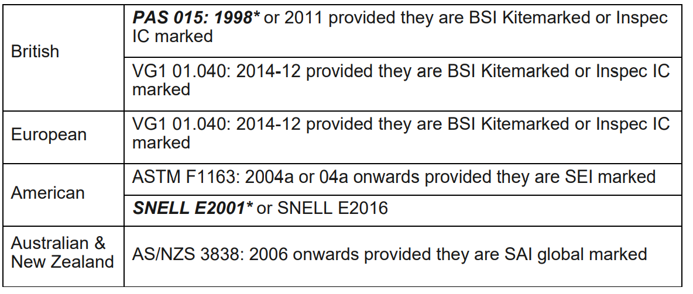
NO DOGS permitted.

PLEASE REMOVE AND TAKE HOME ANY LITTER AND ALL DROPPINGS/HAY LEFT BY YOUR HORSE AROUND YOUR VEHICLE

